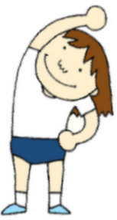
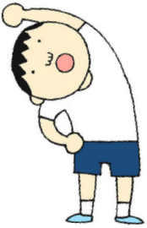
DR. MENG – SHENG LIN ACUPUNCTURE CENTER
2007 N. COLLINS BLUVD SUITE 307
RICHARDSON, TX 75080
972-644-2608

Diaphragmatic Breathing
Hold each position for 10 sec.
Repeat 6 – 10X per position
Perform 1-2X a day

A good place to start is with a simple, yet very effective skill that uses breathing to relax. Breath control is perhaps the oldest known stress-reduction skill and is the foundation to all relaxation skills.

The type of breathing used in relaxation is called diaphragmatic breathing (the diaphragm is the muscle below the lings; it drops down against the stomach when you breathe in and rises when you breathe out). In diaphragmatic breathing, the stomach inflates when you breathe in and deflates when you breathe out, similar to blowing up a balloon. There is essentially no movement in the chest or shoulders. The diaphragmatic breath gets air into the lower parts of the lungs, which increases the amount of oxygen in the blood.

To practice diaphragmatic breathing:

- Sit upright on a chair of lie on your back with your knees bent slightly.
- Place your hands over your navel.
- Completely relax, especially your shoulders and chest, so that they are not moving as your breathe through your nose naturally.
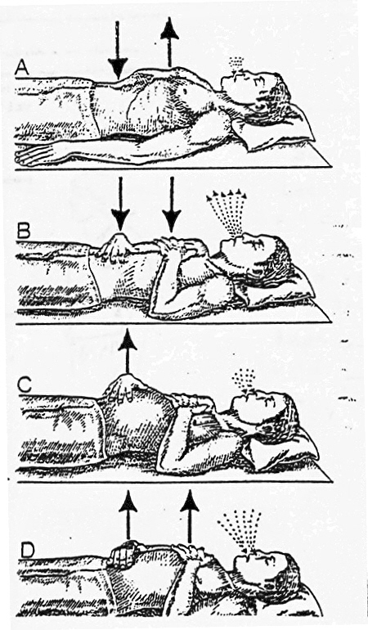
- Let your stomach relax.
- Feel your hands rise as you breathe in and fall as you breathe out.
- Concentrate on your breathing, noticing some of its characteristics.
  - As you breathe in, you might feel slightly refreshed and alert.
  - As you breathe out, tension is released as your diaphragm and rib muscles relax.
  - You will feel a calming, relaxing feeling as your body seems to sink down into the floor or bed.
  - After a few breaths, your breathing becomes slower and more regular.
- Now repeat for a few breaths
- At the very end of each exhalation phase, pull your upper abdomen back and up slightly to push “stale” air out of the area.
- Because this is so relaxing and easy, it may sound silly to say “practice”, but practice until diaphragmatic breathing becomes smooth, natural, and effortless.

NECK AND UPPER EXTREMITY STRETCHING EXERCISES

Flexibility: Neck Retraction |  | Upper Trapezius Stretch
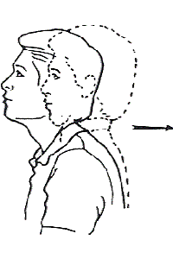 |  | 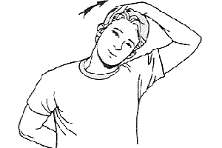
Pull head straight back keeping jaw and eyes level. |  | Gently grasp side of head while reaching behind back with other hand. Tilt head away until a gentle stretch is felt.
_____ Seconds to hold.  _____ Repetitions  _____ Sessions per day. |  | _____ Seconds to hold.  _____ Repetitions - times on each side.  _____ Sessions per day.
Upper Cervical Flexion Mobilization |  | Inferior Capsule Stretch
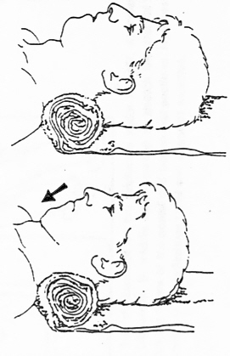 |  | 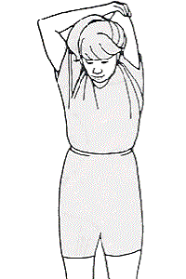
Lying down with neck supported on towel roll and back of head resting on surface, gently nod head by bring chin toward throat. Maintain surface contact with back of head. |  | Gently pull on elbow with opposite hand until a stretch is felt in shoulder.
_____ Seconds to hold.  _____ Repetitions  _____ Sessions per day. |  | _____ Seconds to hold  _____ Repetitions per set.  _____ Sets per session  _____ Sessions per day
Flexibility: Corner Stretch |  | Phase I: Shoulder Shrugs
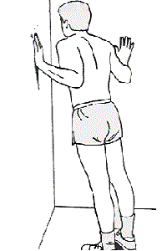 |  | 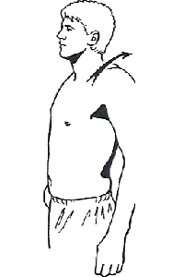
Standing in comer with hands at shoulder level and feet ______ feet from comer lean forward until a comfortable stretch is felt across chest. |  | Shrug shoulders up and down, forward and backward.
_____ Seconds to hold.  _____ Repetitions  _____ Sessions per day. |  | _____ Seconds to hold.  _____ Repetitions  _____ Sessions per day.

NECK AND UPPER EXTREMITY STRETCHING EXERCISES

Shoulder: Posterior Capsule Stretch |  | Shoulder Blade Squeeze
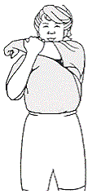 |  | 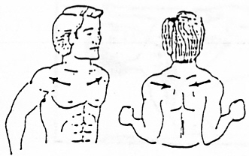
Gently pull on elbow with opposite hand until a stretch is felt in shoulder. |  | _____ Repetitions  _____ Sessions per day.
In-doorway stretch exercise for the Pectoralis Major muscle |  | Trapezius Stretch Exercise
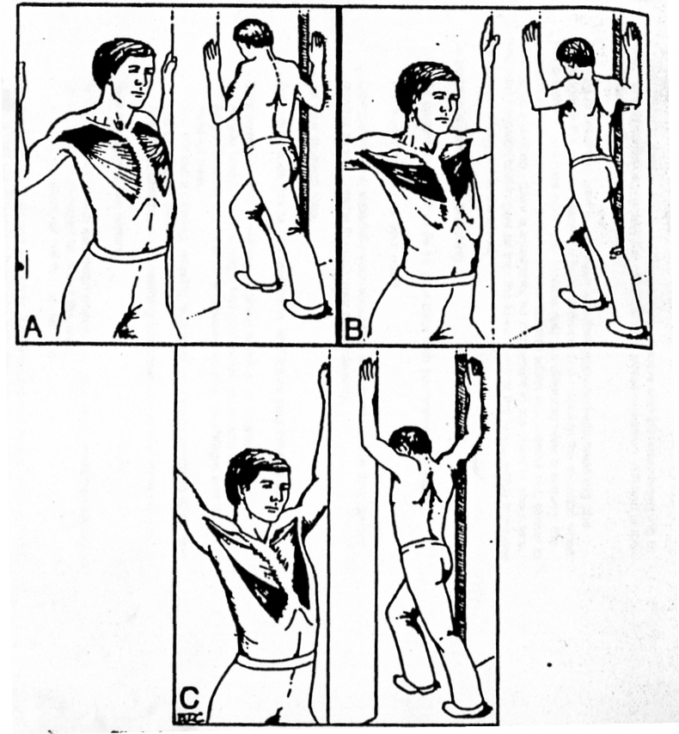 |  | 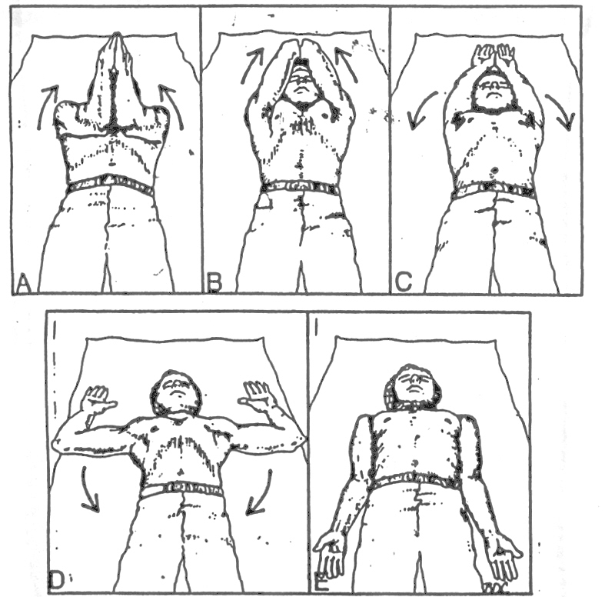
- Lower hand position to stretch the calvicular section bilaterally.  - Middle hand position to stretch the sternal section bilaterally.  - Upper hand position to stretch the fibers of the costal and abdominal sections. Hyperextension of the low back is optional for additional stretch of the latissimus dorsi and iliposoas muscles. |  | Designed to stretch the middle and lower parts of the trapezius muscle by fully abducting and rotating the scapulae. Movements progress from A through E. When completed, the patient pauses, breathes deeply to relax and repeat the sequence.
_____ Seconds to hold.  _____ Repetitions  _____ Sessions per day. |  | _____ Repetitions  _____ Sessions per day.

