How to Stretch:  Stretching should be done slowly without bouncing. Stretch to where you feel a slight, easy stretch. Hold this feeling for 5-30 seconds. As your hold this stretch, the feeling of tension should diminish. If it doesn’t, just ease off slightly into a more comfortable stretch. The easy stretch reduces tension and readies the tissues for the developmental stretch.  After holding the easy stretch move a fraction of an inch farther into the stretch until you feel tension again. This feeling of stretch tension should also slightly diminish or stay the same. If the tension increases or becomes painful, your are overstretching. Ease off a bit to a comfortable stretch. The developmental stretch reduces tension and will safely increase flexibility.  Hold only stretch tensions that feel good to you. The key to stretching is to be relaxed while you concentrate on the area to be stretched. Your breathing should be slow, deep and rhythmical. Don’t worry about how far you can stretch. Stretch relaxed and limberness will become just one of the many by-products of regular stretching.  *Note: if you have had any recent surgery, muscle or joint problem, please consult your personal health care professional before starting a stretching or exercise program.  *The dotted areas are those areas of the body where you will most likely feel the stretch. |  |  | Before:
 |  |  | 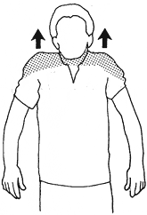  1  Shoulder Shrug. Raise the top of your shoulders toward your ears until you feel slight tension in your neck and shoulders. Hold this feeling of tension for 3-5 seconds, then relax your shoulders downward into their normal position. Do this 2-3 times. Good to use at the first signs of tightness or tension in the shoulder or neck area. |  | 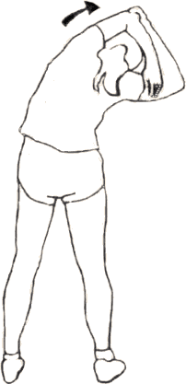  2  With arms overhead, hold the elbow of one arm with the hand of the other arm. Keeping knees slightly bent (1 inch) gently pull your elbow behind your head as your bend your hips to the side. Hold an easy stretch for ten seconds. Do both sides. Keeping your knees slightly bent will give you better balance. |  | 3  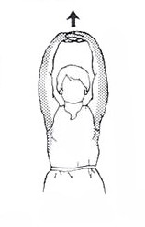  Interlace your fingers above your head. With your palms facing upward, push your arms slightly back and up. Feel the stretch in arms, shoulders and upper back. Hold stretch for 15 seconds. Do not hold your breath. This stretch is good to do anywhere, anytime.
4  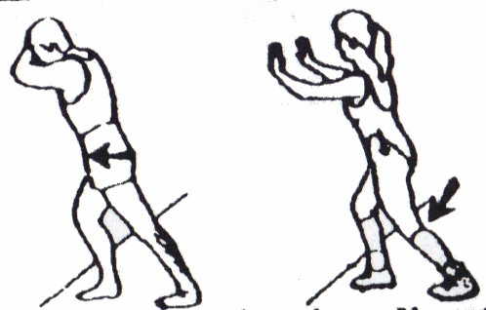  To stretch your calf, stand a little ways from a solid support and lean on it with our forearms, your head resting on your hands. Bend one leg and place your foot on the ground in front of you leaving the other leg straight, behind you. Slowly move your hips forward until you feel a stretch in the calf of your straight leg. Be sure to keep the heel of the foot of the straight leg on the ground and your toes pointed straight ahead. Hold an easy stretch for 30 seconds. Do not bounce. Now, to stretch the soleus and Achilles tendon, slightly bend the back knee, keeping the foot flat. This gives you a much lower stretch which is also good for maintaining or regaining ankle flexibility. 15 seconds, each leg. This area needs only a slight feeling of stretch. Stretch both legs. |  | 5  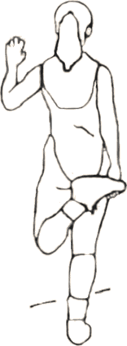  Opposite hand to opposite foot – quads and knee stretch: Hold top of right foot (from inside of foot) with left hand and gently pull, heel moving toward buttocks. The knee bends at a natural angle in this position and creates a good stretch in knee and quads. Hold for 15-20 seconds. Do both legs. | 6  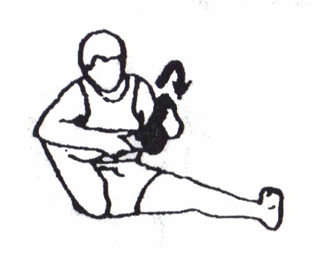  Rotate your ankle clockwise and counterclockwise through a complete range of motion with slight resistance provided by your hand. Rotary motion of the ankle helps to gently stretch our ligaments. Repeat 10-20 times in each direction. Do both ankles. |  | 7  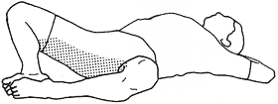  Relax with your knees bent and the soles of your feet together. This comfortable position will stretch your groin. Hold this position for 30 seconds. |  | 8  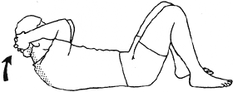  Interlace your fingers behind your head and rest your arms on the mat. Using the power of your arms, slowly bring your head, neck, and shoulders forward until you feel a slight stretch. Hold an easy stretch for 5 seconds. Repeat 3 times. Do not overstretch.
9  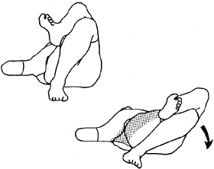  From a bent knee position, interlace your fingers behind your head and lift the left leg over the right leg. From here, use your left leg to pull your right leg toward the floor until you feel a stretch along the side of your hip and lower back. Stretch and relax. Keep upper back, shoulders and elbows flat on the floor. The idea is not to touch the floor with your right knee, but to stretch within your limits. Hold for 20-30 seconds. Repeat stretch for other side. |  | 10  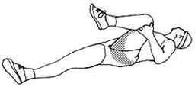  Next, straighten both legs and relax, then pull your left leg toward your chest. For this stretch, keep the back of your head on the mat, if possible, but don’t strain. Hold an easy stretch for 30 second. Repeat, pulling your right leg toward your chest. | 11  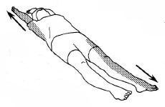  Straighten out your arms and legs. Point your fingers and toes as you stretch as far as you can. Stretch and then relax. This is a good stretch for the entire body. Hold for 5 seconds. |  | 12  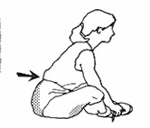  Put the soles of your feet together with your heels a comfortable distance from your groin. With your hands around your feet slowly contract your abdominals to assist you in flexing forward until you feel an easy stretch in the groin. Make your movement forward by bending from the hips and not from the shoulders. If possible, keep your elbows on the outside of your lower legs from greater stability during the stretch. Hold a comfortable stretch for 20-30 seconds. |  | 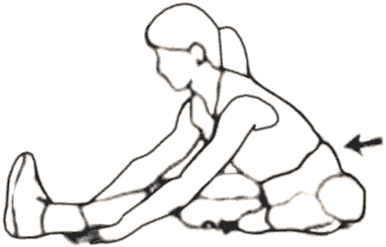  13  Sitting, straighten your right leg, the sole of your left foot resting next to the inside of your straightened leg. Lean slightly forward from the hips and stretch the hamstrings of right leg. Find an easy stretch and relax. If you can’t touch your toes comfortably, use a towel to help you stretch. Hold for 50 seconds. Do not lock your knee. Your right quadriceps should be soft and relaxed during the stretch. Keep your foot upright with the ankle and toes relaxed. Do both legs. Breathe relaxed.
After:
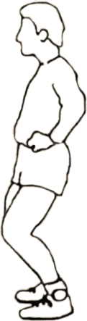  1  Stand in this bent-knee position which contracts the quadriceps and relaxes the hamstrings. Hold for 30 seconds. Because these muscles have opposing actions, tightening the quadriceps will relax the hamstrings. As you hold this bent-knee position, feel the difference between the front of the thigh and the back of the thigh. The quadriceps should feel hard and tight while the hamstrings should feel soft and relaxed. | 2  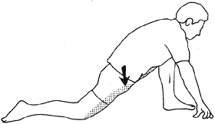  As shown in the drawing above, move one leg forward until the knee of the forward leg is directly over the ankle. Your other knee should be resting on the floor. Now without changing the position of the knee on the floor or the forward foot, lower the front of your hip downward to create an easy stretch. This stretch should be felt in front of the hip and possibly in your hamstrings and groin. This will help relieve tension in the lower back. Hold the stretch for 20-30 seconds. Repeat for the other leg. |  |  | 3  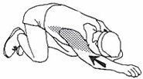  With legs bent under you, reach forward with one arm and grab the end of a mat, carpet or anything you can hold onto. If you can’t grab onto something just pull back with your arm straight while pressing down slightly with your hand. (do likewise pulling on end of mat). Hold stretch for 20 seconds. Stretch each slide. Don’t strain. You should feel the stretch in your shoulder, arms, sides, upper back, or even in your lower back. |  | 4  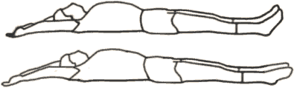  Straighten out your arms and legs. Point your fingers and toes as you stretch as far as you can. Stretch and then relax. This is a good stretch for the entire body. Hold for 5 seconds. |  | 5  Stretch diagonally. Point the toes of your left foot as you extend your right arm. Stretch as far as is comfortable. Hold 5 seconds, then relax. Stretch the right leg and the left arm the same way.
6  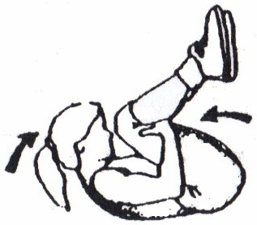  Pull both legs up to your chest. Concentrate on keeping the back of your head down, and then curling your head up toward your knees. Hold for 5-10 seconds. | 7  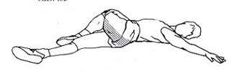  Bend your leg and with your opposite hand, pull that bent leg up and over your other leg as shown above. Turn your head to look toward the hand of the arm that is straight (head should be resting on the floor). Make sure the back of your shoulders are kept flat on the floor. Now, using your hand on your thigh ( resting just above the knee), pull your bent knee down toward the floor until you get the right stretch feeling in your lower back and side of hip. Keep feet and ankles relaxed. Hold a comfortable stretch for 30 seconds, each side. |  |  | 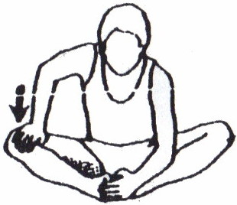  8  Hold on to your feet with one hand, with your elbow on the inside of the lower leg to hold down and stabilize the leg. With your other hand on the inside of your leg (not on the knee), gently push your leg downward to isolate and stretch this side of the groin. Hold for 25-30 seconds each side. This is a very good isolation stretch for people who want to limber up a tight groin so that the knees can fall more naturally downward. |  | 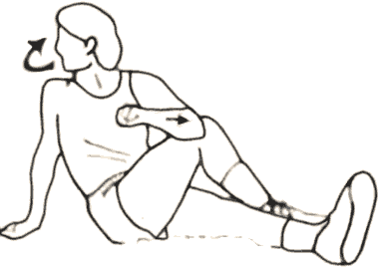  9  With your left foot resting to the outside of your right knee, pull your knee across your body toward your opposite shoulder until an easy stretch is felt on the side of the hip. Hold for 20 seconds. Do stretch to both sides. |  | 10  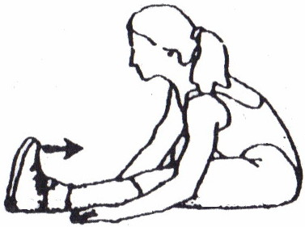  Slowly pull your toes back toward your shin until you can go no further, the stop and hold the foot dorsi-flexed. Next, slowly bend at the thigh joints until you feel a stretch in the back of the lower leg. Hold this stretch for approximately 10-15 seconds as you keep the foot dorsi-flexed.
11  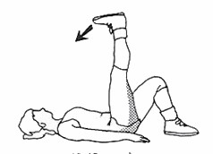  Lay on your back, life your leg up toward a 90 degree angle at the thigh joint. Keep the low back flat against the floor during the stretch. Hold stretch for 15-20 seconds. Do both legs. | 12  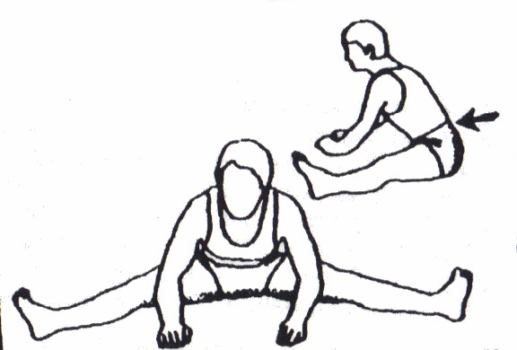  Sit with your feet a comfortable distance apart. To stretch the inside of your upper legs and hips, slowly lean forward FROM THE HIPS. Be sure to keep your quadriceps relaxed and feet upright. Hold for 30 seconds. Keep your hands out in front of you for balance and stability or hold onto something in front of you for greater control. Concentrate on keeping the lower back flat as you do this stretch. Do not strain |  |  | 13  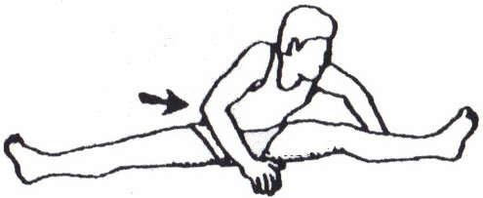  To stretch your left hamstrings and the right side of your back, slowly bend forward from the hips toward the foot of your left leg. Hold for 30 seconds. Repeat to other side. |  | 14  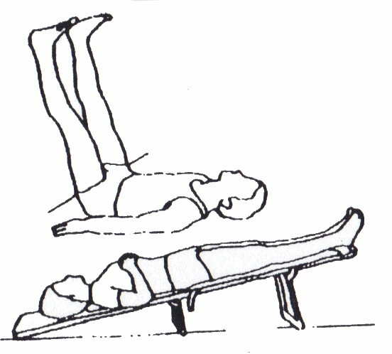  Elevate your feet. It is great for circulation and revitalization of tired legs and mind. Your lower back should be flat and not arched off the floor. Do not elevate for too long in the beginning, gradually increase the time (1-5 minutes, or longer).

