The Dallas Morning News
Pinpointing the FAT
Doctor offers the option of acupuncture to patients having liposuction done
Steve Levin Special Contributor to The Dallas Morning News
Published: August 29, 1994
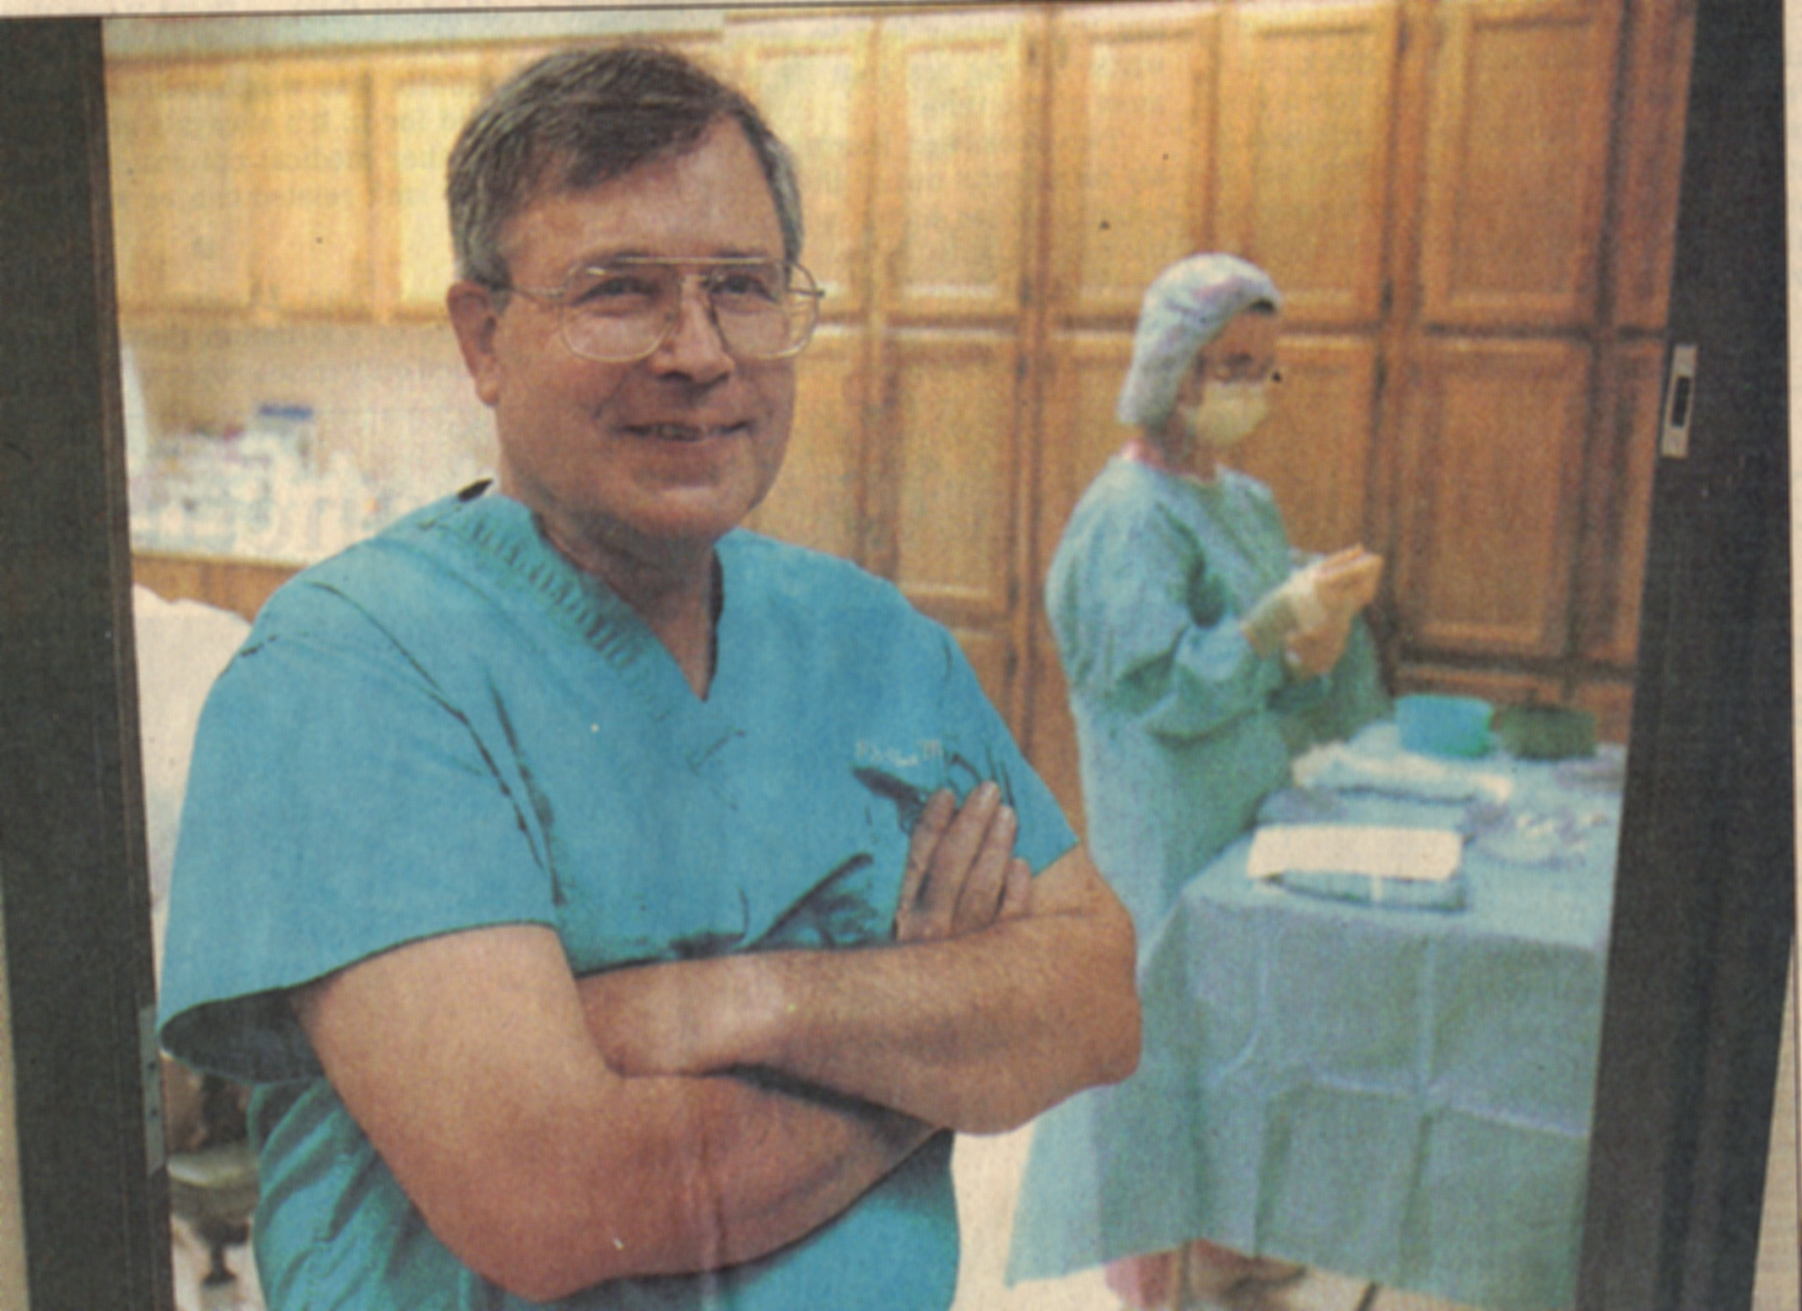
The items in question aren't very long - 1 to 3 inches at most - and are so thin as to be nearly invisible. For most of Dr. P.J. Chandler Jr.'s liposuction patients, this will be their first experience with acupuncture. Some are nervous initially about hav- ing eight to 10 needles inserted into their shins, hands and abdomen. But they figure - as an alternative way to alleviate pain, avoid general anesthesia and save money while fat is vacuumed from their bodies - it's worth a try.
Dr. Chandler is sanguine about the process. A board-certified plastic surgeon whose private practice is in Richardson, he likes to cast his use of acupuncture in an "East meets West" medical vein. Ensconced in his small, neat office, where he furtively rolls his own cigarettes and flicks the ashes (mostly unsuccessfully) into a trash can, he says: "Eastern medicine as practiced in China has been going on a few thousand years. It is not something that has been written about much in the American literature. In other words, people may not understand (acupuncture) or understand whether it works or not.
"(But) the plastic surgeon is an innovator. Most plastic surgeons are people who are willing to look at things that are new and different and understand what works and doesn't work. Our experience has shown that acupuncture does work."
Carolyn Williams, who had liposuction performed by Dr. Chandler on her thighs in 1993, says she often tells people about her experience.
"The first reaction when I say `acupuncture' is their eyes shoot up," she says.
"It immediately sets a fear in them, the thought of having those little needles in them. You don't even feel those needles. It does eliminate a certain amount of pain. It definitely works."
Of the more than 1,500 members of the American Academy of Cosmetic Surgery, the largest national organization of cosmetic surgeons, Dr. Chandler, 54, is the only physician known to use acupuncture during liposuction.
According to the academy, about 90,000 liposuctions were performed by its members in the United States from March 1993 through March 1994. However, the total number of liposuctions performed could be three times as many, says the academy's president, Dr. Howard Tobin of Abilene, because the academy represents only one-third of all people in the United States performing liposuctions.
The acupuncturist
During the past four years, Dr. Chandler has done an estimated 100 procedures using acupuncture. Though he deals with his liposuction patients throughout the pre-operative, operating and post-operative times, the acupuncture itself is done by Meng-Sheng Lin, a general surgeon from China and a certified acupuncturist who has worked with Dr. Chandler since 1989.
As Dr. Chandler is quick to point out, the use of acupuncture is his only departure from the operating procedures followed by the majority of licensed cosmetic surgeons who perform liposuction. At his outpatient surgery center, liposuction patients are given a mild sedation and local anesthesia in addition to the acupuncture.
Acupuncture allows the patient to avoid the potentially life-threatening risks of general anesthesia and to use less pain medication both before and after the procedure. The patient is able to talk and move throughout the liposuction. Toward the end of the procedure, the patient is able to stand, allowing Dr. Chandler better access for fat removal and to see the effect of gravity in making fat deposits more visible.
Initially, Dr. Chandler himself was skeptical of acupuncture's efficacy in the liposuction procedure. But "I found (Meng-Sheng Lin's) ability to control pain was so good with so many difficult kinds of problems that we see in plastic surgery."
He decided to try it in some small liposuction procedure, "an area which I probably could have done under local (anesthesia) without any acupuncture at all," he says.
"We used acupuncture to see if it made any difference in the patients' responses to the procedure. In the first case (he worked with Meng-Sheng Lin), I said, `What are you doing?! You're taking the needles out! And we haven't done the case yet!' And she said, `It's done.' I didn't know any different."
The acupuncture needles stimulate endorphins, the substances released by the brain that have a pain-relieving effect like that of morphine. In addition, the locations where the needles are placed "block," or inhibit, the swelling that normally accompanies the procedure.
Meng-Sheng Lin, a slight woman who also worked at the
Acupuncture Center in Richardson, is better-known to her patients and Dr. Chandler as Linda. Forty-five minutes before the
liposuction is scheduled to begin, she carefully begins inserting the needles into the patient.
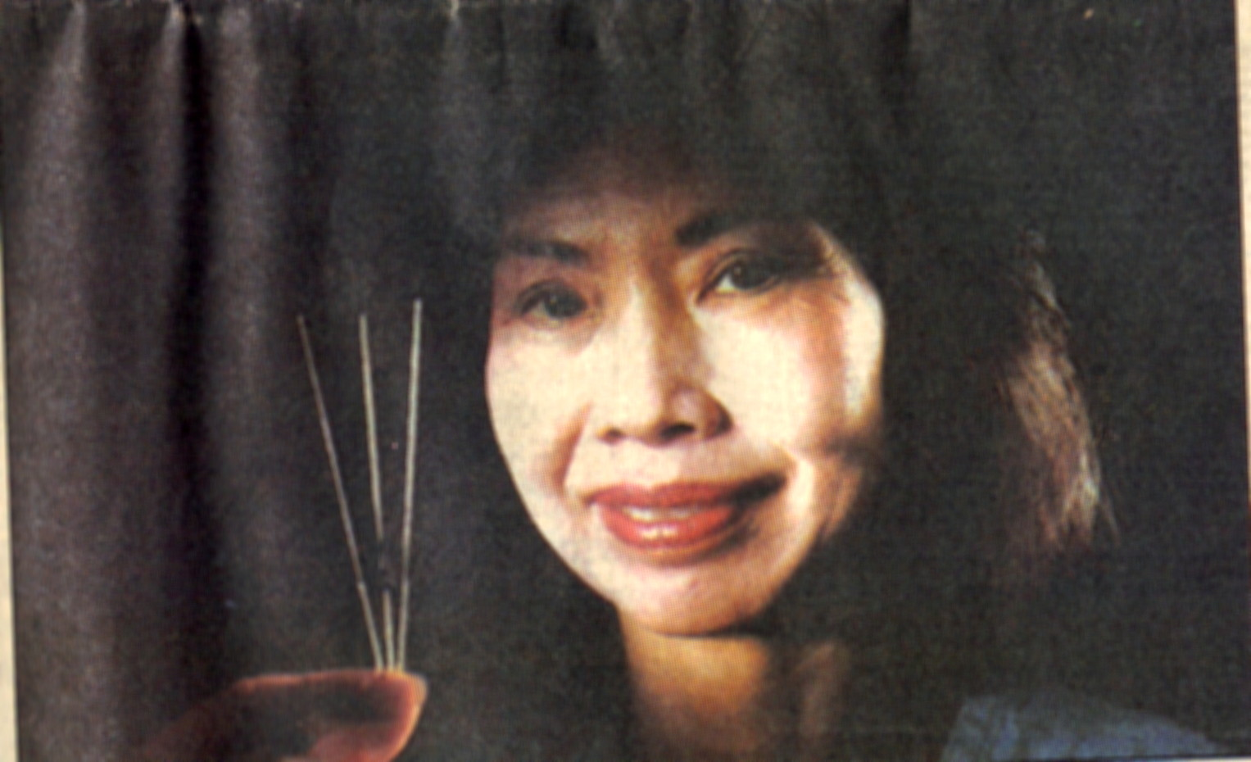
Once they are in, she sends a slight electrical charge pulsing through them for 45 minutes, stimulating the endorphins. The needles are removed before the surgery but the pain relief lasts from two to four hours, she says, increasing a patient's pain threshold threefold.
"The patients feel very comfortable," she says. "There are less side effects and they recover quickly. They just feel good."
Acupuncture chosen
Although Carolyn Williams had never had acupuncture before, when she decided to have liposuction performed on her thighs in 1993 she opted for it.
"I felt real good about it," says Ms. Williams, 50, who lives in Plano. "I was aware when they were putting the needles in. It did not hurt. It really had a kind of soothing effect. I did not experience any pain during the procedure, and I think it was because of the acupuncture."
Ms. Williams says she heard of Dr. Chandler through some friends. "People probably are just not aware of him. There are so many doctors out there doing cosmetic surgery," she says.
Dr. Chandler, in private practice since 1973, says the procedure has not led to increased business.
"I'm not trying to push it because people might consider it a gimmick. It's not a gimmick. It works.
"I think it (the increased business) comes with time. It comes by word of mouth."
Dr. Chandler says that if patients prefer general anesthesia over acupuncture, however, he accommodates them and does the procedure at a local hospital.
However, with the additional cost of in-patient hospital care and an anesthesiologist, the cost of that surgery is $5,000, about twice the charge for Dr. Chandler's in-office procedure.
"I would say that it would be very difficult to evaluate the effectiveness of the acupuncture when he's using other sedatives," says Dr. Tobin of the American Academy of Cosmetic Surgery, who uses general anesthesia at his Abilene clinic.
"I wouldn't be critical of what he's doing, but I would certainly question how important the acupuncture is to the overall effectiveness of the procedure."
Doctor approves
Dr. Saul Asken, author of three textbooks about liposuction and head of the Cosmetic Surgery Center of Connecticut, says he thinks using acupuncture "is a wonderful idea." Dr. Asken, who estimates he has performed about 6,000 liposuction procedures during the past 10 years, says the acupuncture cuts down the amount of sedation a patient requires. He himself does not use acupuncture.
"There's no question that acupuncture helps in reducing the pain in acting as an anesthetic," Dr. Asken says. "He's bypassing a number of drugs, which is wonderful. I'm delighted he's doing it."
Dr. Chandler's willingness to use acupuncture - a medical practice still considered "alternative" in the West - is not all that surprising given the road he has traveled. At age 13 he suffered polio. Even today, he can't stand for long periods of time (he performs liposuctions while seated on a stool).
While in medical school 10 years later, he was diagnosed as having a malignant tumor on the right side of his forehead. Three times he endured surgery; he credits the plastic surgeon who performed the third operation with "saving my life."
Afterward, "I wanted to do something in medicine that allowed me to use hand-to-eye coordination where I didn't have to stand up long." During his surgery residency at the Barnes Hospital in St. Louis, he was exposed to top-level plastic surgeons and decided to become one himself.
A Navy veteran of Vietnam, Dr. Chandler has continued to pursue educational avenues, earning a master's in both business
administration and in international management studies from the University of Texas at Dallas, studying immunology and taking a business law course. "It's the way to keep your brain young," he says.
As for using acupuncture for himself - as a way to stop smoking, for example - he's unsure.
"I have done acupuncture in the past (to stop smoking) and it did work for a period of time," he says. "But right now, I don't feel like stopping."
Steve Levin is a writer and editor in Austin.
PHOTO(S): 1. Dr. P.J. Chandler Jr. finds acupuncture
reduces the need for pain-killing medication in liposuction
procedures. 2. Meng-Sheng Lin is a general surgeon and certified
acupuncturist who works with Dr. Chandler. 3. Meng-Sheng Lin
displays the disposable acupuncture needles and the electric
stimulator used in Dr. P.J. Chandler's office in Richardson. (The
Dallas Morning News: David Woo); PHOTO LOCATION:
Copyright 1994 The Dallas Morning News Company

