Pain Evaluation

Name___________________________________ Date___________________________

SSN: ____-____-_____ D.O.B.____-____-____ Age:______ Sex: Male___ Female___

Chief Complaint ____________________________________________ DOI: _________

1. Pain is difficult to describe. Circle the words that best describe your symptoms:

Burning Throbbing Aching Stabbing Tingling Dull

Twisting Cramping Cutting Shooting Numbing Vague

Stinging Squeezing Pulling Smarting Pressure Coldness

Indescribable Other: _____________________________________

2. Mark your average level of pain in the last month?

_________________________________________________
No Pain Most Severe Pain

3. How is your mood now? ______________________________________________
Best Mood Worst Mood
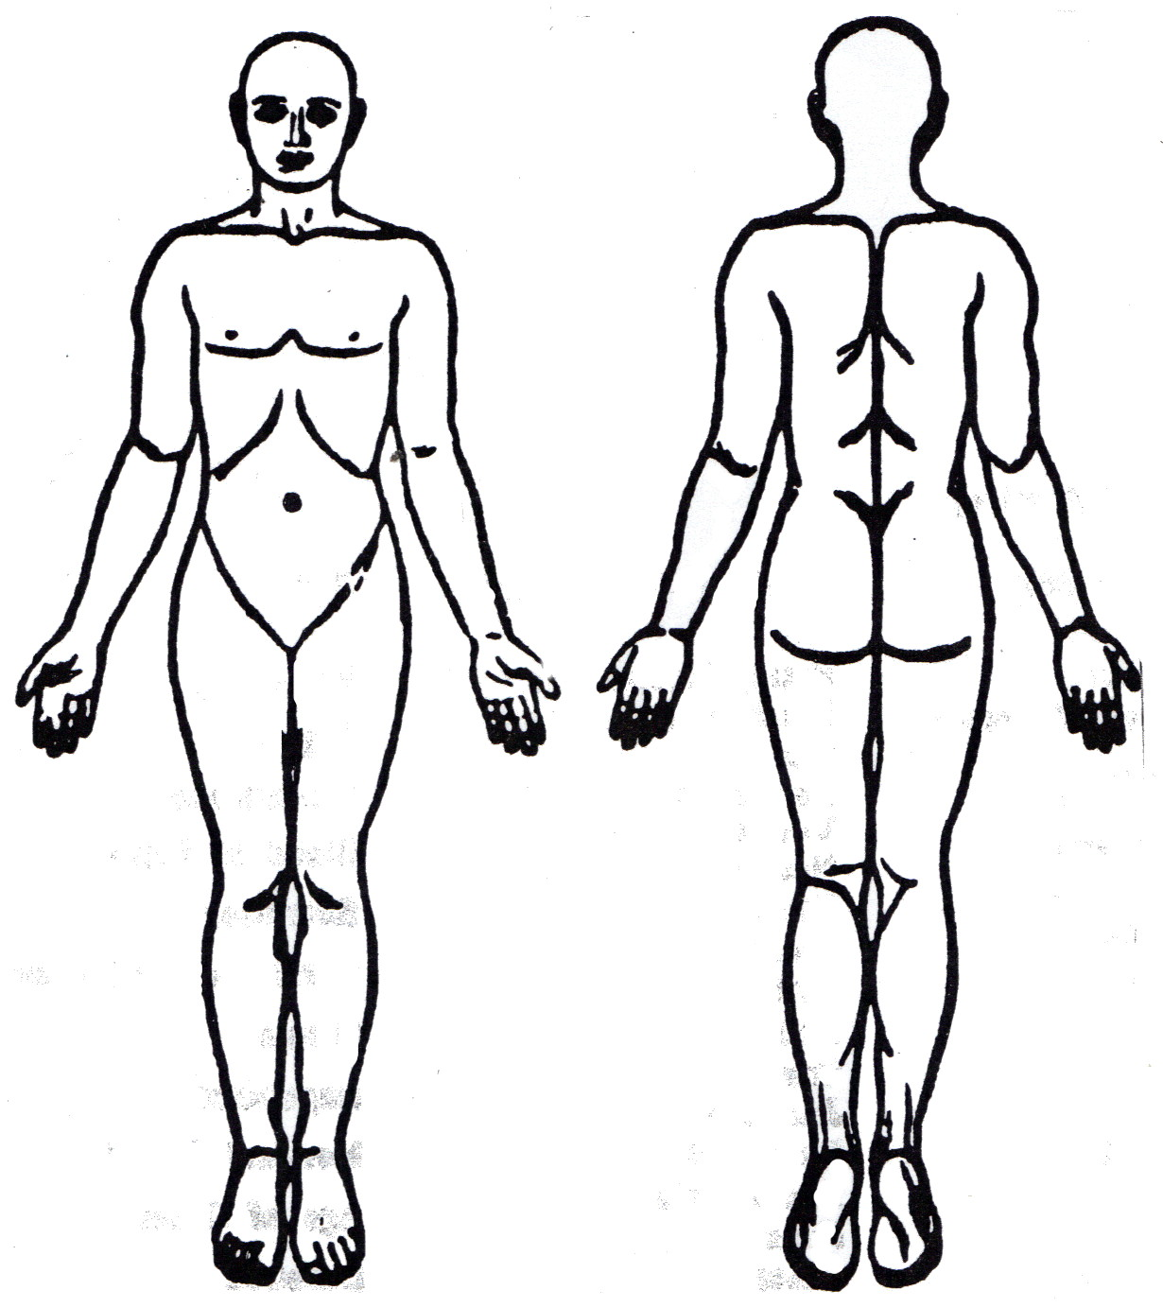
4. Where is your pain? (Draw on diagram)

