Dr. Meng-Sheng Lin, L.Ac.
Dr. Meng-sheng Lin Acupuncture Center
2007 N. Collins Blvd. Suite 307, Richardson, TX 75080
Tel/Fax: (972)644-2608 Email: dr_mengsheng_lin@yahoo.com
Website: www.dallasacupuncturecenter.com

Stop Aging or Slow the Process

Exercise With Oxygen Therapy (EWOT)
Can Help
William Campbell Douglass, MD

What is EWOT?
EWOT stands for Exercising with Oxygen Therapy. This method of prolonging your life is so simple that it’s hard to believe it could work, but it does and you can do it at home at a minute cost.
When your cells don’t get enough oxygen, they degenerate and die and so you degenerate and die. Exercising, while breathing oxygen, dramatically increase the amount of oxygen in the blood plasma. After 15 minutes of EWOT, the oxygen content of this fluid can be dramatically increased and thus oxygen will be “pushed” into the body’s cells without the aid of red cells, giving you “oxygen-rich blood.”

The Benefits Are Universal
If doing simple exercise daily for 15 minutes while breathing oxygen through your nose which enables you to have an oxygen status higher than the average 30-year-old, would you be interested in such a treatment? Numerous studies have proven the effectiveness of treating Heart Failure, Alzheimer’s, Emphysema, High Blood pressure and Stress, won’t you want to give it a try?

Oxygen and Your Body
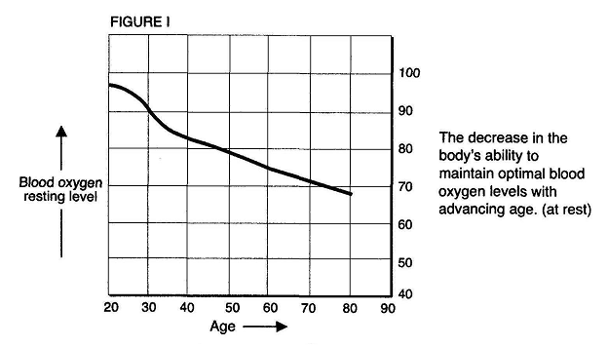
You really don’t have to start dying at 20. But most of us do. By age 40 we have lost 20 percent of your oxygen-utilization ability and, by age 60, we have lost almost 40 percent of our ability to absorb and burn oxygen, our essential “fuel.” The measurement of the oxygen content of the arteries, indicated on your oximeter, is called the pO2. A normal pO2 is between 80 and 100. If you are down around 60, you have emphysema, cancer, or you have be hanging around the pool hall too much. If you are down to 40 then you are really in trouble, you won’t be walking around if you have a pO2 at that level.
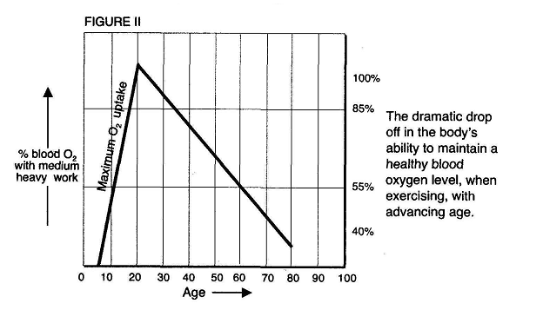
In an experiment, 108 patients with a mean age of 68 (many were much order than 68; one was 86) received 23 days of EWOT therapy. Their pO2 went up an average of 20 point (starting at 67 and increased to 87). As a bonus, their blood pressure also has significant decrease.
According to study, besides aging, after events including major operations, cancer chemotherapy, X-ray therapy, extensive burns, and stress can cause dramatically decrease in ones pO2 level.
One of the mysteries of EWOT is that once the blood oxygen level, as measured by the pO2 is brought up to a high normal level, it will remain there until some other stressful event takes place. So you don’t have to take EWOT everyday for the rest of your life; just take it when needed.

Putting It into Practice
There are infinite varieties of ways that you can take EWOT. If you are going to use a tread mill or stationary bicycle, get a large tank of oxygen from the medical supply store. If you really want to look cool, and are physically fit, get a small bottle and wear it on your back while you ride your bicycle around town. If you are little old and run down, you can settle for something less strenuous, like light or medium-heavy bar bells which you can do it in bed and work up form there. Just 15 minutes a day, you might become the oldest winner of the Tour de France bike race.
If you are young and healthy, it will delay the aging process. If you are young and sickly, it may help your illness. If you are over the age of 50, no matter what your state of health, EWOT is your solution.

